Introduction and Problem Statement
Nowadays, within the curriculum of Mechatronics Engineering major, practical experience in assembling and analyzing circuitry is proven to be essential for bridging theoretical knowledge and real-world hardware implementation. The purpose of this project is to improve my practical skill in soldering and also to help me learn the fundamental knowledge about electronics and also to learn how to work with a soldering iron. And also, it’s a gift to my beautiful girlfriend who has always been there for me. In this project, I explored waveform generation, signal amplification, and system integration through the assembly of the HBL-22Rev1.0 Heart-shaped breathing LED kit, produced by YiQi. This project addresses the problem of understanding how low-power integrated circuits can be interfaced with current-amplifying components to drive higher-power parallel loads, serving as steppingstonee toward more advanced mechatronic system designs.

I. Technical objectives.
The primary technical objective of this project is to successfully assemble the provided printed circuit board and evaluate its electronic characteristics. Secondary objectives include analyzing the schematic to comprehend the operating principle of analog oscillation, identifying the precise role of both active and passive components within the circuit, and conducting empirical measurements to verify theoretical power consumption. Furthermore, the project aims to establish strict soldering safety and quality assurance practices while identifying concrete pathways for future hardware upgrades.
II. Circuit Overview and Block Diagram
The overall architecture design of the HBL-22 kit can be visualized as a sequential flow of power and control signals. 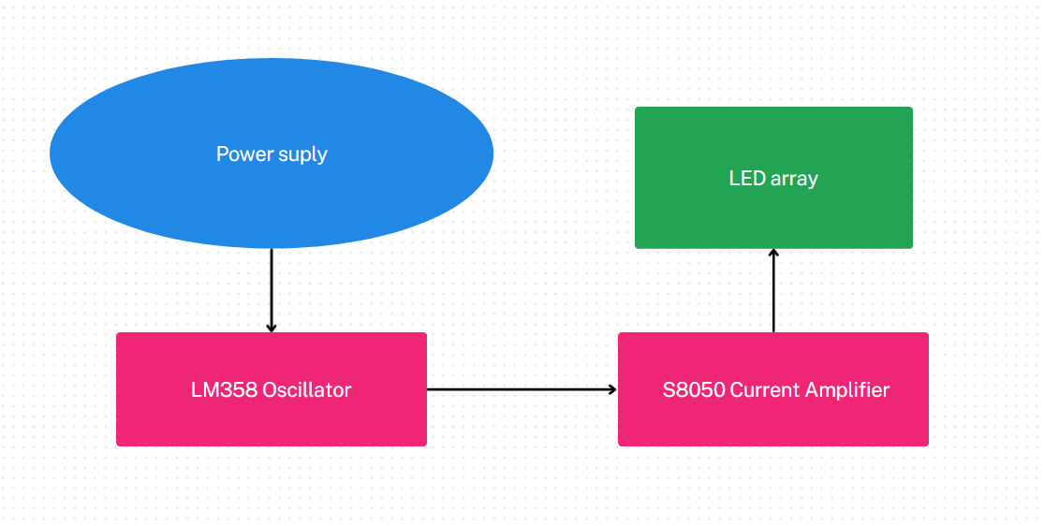
Block diagram of the HBL-22 kit

As illustrated in the diagram above, the circuit begins with a direct current power supply that energizes the entire circuit. This power feeds into an oscillator centered around an operational. The op-amp generates a continuously varying control voltage, which is then passed to a current amplifier stage. Finally, the amplified current drives the terminal load, which consists of 22 LEDs arranged in parallel, creating a smooth fading visual effect.
III. Component list and roles.
HBL-22 heart-shaped breathing LED component list
No. | Name | Mode | Quantity
R5 | RES | 22R | 1
R6 | RES | 10K | 1
R1, R2, R4 | RES | 47K | 3
R3 | RES | 100K | 1
C1 | E-CAP | 47UF | 1
VR1 | ADJ-RES | 50K | 1
U1 | IC | LM358 | 1
S1 | POWER SWITCH | 6P | 1
Q1 | TRIODE | S8050 | 1
LED1 -22 | LED | 5mm | 22+2
 | PCB | HBL-22 | 1

The LM358 operational amplifier acts as the core control unit of the circuit, configured alongside the resistor-capacitor network to function as a low-frequency oscillator. It generates a triangle or sine-like varying voltage waveform. The S8050 NPN transistor serves as a vital current amplifier. Because the LM358 operational amplifier cannot source sufficient direct current to illuminate twenty-two LEDs simultaneously, the transistor utilizes the weak oscillating voltage at its base to regulate a proportionally larger current flow from the collector to the emitter. The 50K Ohm adjustable potentiometer is integrated into the RC timing loop of the operational amplifier, allowing the user to dynamically alter the RC time constant and thereby control the oscillation frequency.
Meanwhile, the remaining fixed resistors serve multiple roles: several are used to set the necessary voltage dividers and feedback loops for the LM358, while the 22 Ohm resistor acts as a strict current-limiting component to protect the LED array from thermal runaway. Finally, the power supply configuration was selected to operate between 4 and 6 Volts. This specific voltage level was chosen because the red LEDs require an optimal forward voltage of approximately 4V, while other color variants operate safely up to 6V. A standard USB supply or a 3xAA battery box can also be used to provide sufficient current capacity to drive the heavy parallel load of the LED array continuously.
IV. Operating Principles
The circuit relies on analog waveform generation to create its signature visual output. When power is applied, the LM358 operational amplifier and its associated RC network begin charging and discharging the 47uF electrolytic capacitor. This continuous cycle produces a slowly oscillating voltage signal. This varying voltage is fed directly into the base of the S8050 transistor. As the base voltage smoothly rises, the transistor allows an increasing amount of current to flow through the parallel LED array, causing the lights to gradually brighten. As the capacitor discharges and the base voltage falls, the transistor restricts the current, causing the LEDs to smoothly dim. This cyclic rising and falling of current generates the "breathing" illumination effect.

V. Assembly Process
The assembly process was quite simple because of the easy-to-follow instructions provided by the manufacturer. First, a thorough schematic review was conducted to understand component polarities and system layout. Second, a component test was performed, by using an Arduino Uno R3 as a stable 3.3V power supply and a bread broad, I was able to check resistor values, verifying the capacitance of the electrolytic capacitor, and ensuring the LEDs functioned correctly. The third step was the physical soldering process, prioritizing the installation of low-profile passive components like resistors before moving on to the transistor, the integrated circuit, the capacitor, and finally the bulky power switch and LEDs. The final step was to make sure that everything worked as intended by making tests and power-on validation.
VI. Measurement Results
After the successful assembly, I used a multimeter to measure the entire circuit; measurements were recorded to evaluate the electrical characteristics of the system. The supply voltage utilized for the operation was 5.02V. Under normal operating conditions, the total current consumption measured across the main power input was 0.045 A to 0.065 A (fluctuating). The estimated power consumption of the circuit is calculated as P = V × I, resulting in 0.25 W.
Observed heat: remained cool to the touch with no significant temperature increase during operation.

Furthermore, the behavior of the main potentiometer was tested. Adjusting the 50KΩ variable resistor directly influenced the circuit's operation by altering the frequency of the breathing cycle, speeding up the fading effect when resistance was decreased, and slowing it down when resistance was increased.
VII. Errors encountered and solutions:
During the assembly and testing phase, I encountered some challenges. A LED failed to illuminate upon pressing the power button. Upon inspection, I discovered that the cause was a cold solder joint that had formed on the connecting pin of that specific LED, and also, I made a mistake during the assembly of that LED by placing the LED in the wrong orientation, causing miss match of the positive and negative polar. This minor inconvenience was solved swiftly by desoldering and reversing the incorrectly orientated LED, after which the circuit performed flawlessly.
VIII. Results and Evaluation:
The completed HBL-22 kit met all initial technical objectives. The circuit successfully demonstrated the principles of operational amplifier oscillation and transistor-based current amplification. The measured power consumption aligned with the theoretical expectations for a parallel array of twenty-two LEDs. The structural integrity of the soldering was validated through continuous, error-free operation. Overall, the project served as an effective practical platform for reinforcing fundamental electronic concepts.

Future Development and Upgrade Suggestions:
To advance this project, immediate hardware improvements should include adding a cleaner power input connector, a physical power switch, a 3D-printed base with grass decorations, and an acrylic sheet to diffuse light and hide the circuitry. For PCB upgrades, the schematic can be redrawn using KiCad or Altium to design a custom heart-shaped board. This allows for the selection of specific LEDs, resistors, and power supplies, alongside the creation of a complete Bill of Materials (BOM) with total cost calculations.
Advanced mechatronics upgrades could transition the circuit to digital control by integrating a capacitive touch button for mode switching, a microcontroller for PWM brightness dimming, a light sensor for automatic night dimming, and an auto-off timer. The power supply could also be modernized to a rechargeable battery featuring a protection circuit and USB Type-C charging. Applying these concepts, suggested future projects include a smart night light, a sound-reactive LED name board, or an automated gift box utilizing distance sensors and servo motors.

Conclusion
Building the HBL-22 Heart-Shaped Breathing LED Kit helped me connect classroom theory with real-world practice. By making this device, I clearly saw how the operational amplifier (LM358) creates the signal and how the transistor (S8050) controls the electric current to light up the LEDs. This project taught me important lab safety and soldering skills. It also showed me the limits of simple analog circuits, which gives me good ideas for future digital upgrades.
Special thank to TS. Nguyễn Anh Dũng for entrusting me with this task.

